Step 0 Intake + Interview Filing Status, Dependency

Interview Notes: (See also: General Notes)
- Andrea paid $1,000.00/month rent for the current tax year.
- Andrea paid $167 in student loan interest in the current tax year

Documents:

Step 1 Basic Information

TP Form / Note | TS Screen | Notes
SS Card | Start a New 2018 Tax Return  Available Taxpayer Profiles | Ignore the Profiles  Select “Enter Social Security Number” at the bottom of the screen  Enter the TP SSN twice and “Start Return”
Intake Sheet | What is your filing Status? | TS Answer: Filing Status: Single”  TS: “Continue”
SS Card  Intake Sheet  G-Note 2 | Personal Information  Taxpayer Information  Address & Phone Number | TS: Enter all information using “Caps Lock”  Hint: Use Name and SSN from SS card. (Not Intake Sheet)  Hint: SSN format YYY-00-0752  TS: Birth date can be entered using drop down menu or filling in the field.  TS: Check any of the “Check here” questions that apply  - There are none  TS: Enter Zip code- TaxSlayer fills in city and state. Correct if required  TS: Enter New Jersey as the Resident State  TS: “Continue”
Intake Sheet | New Jersey Return  NJ Property Tax Credit or Deduction  Do you meet Property Tax  Credit or Deduction  Eligibility Requirements?  Taxpayer NJ Health Insurance  Does the Taxpayer have  Health Insurance?  New Jersey Return  Select the County or  Municipality of your  current residence | Begin New Jersey Checklist  TS Answer: At this point answer “No”. We will go back and adjust after the Federal Return is complete  TS Answer: “Yes”  Use “NJ Municipality Code lookup in Tax Prep 4 Free  Left click in the box. Type in Bergen. Scroll down to BERGEN - -EDGEWATER BORO  At this point just hit ““Continue”” We will go back and adjust after the Federal Return is complete
 | Dependents or Qualifying Child Information  Do you have any Dependents or Qualifying Person(s) to claim on your return? | TS: Answer is “No”

Federal AGI: 0 Federal Refund: 0 NJ Refund Amount: 0

Step 2 W-2 Billings Market

W-2  Billings Market | Left Menu – Federal Section  Income  Wages & Salaries Form W-2  Begin  Complete W-2 Information- | Hint: Make corrections so that information matches the information on the paper W-2.  - TP address shown on the TS W-2 should match the paper W-2  - If the name and address of the employer come up after inputting the employer Identification Number, check that the information matcher the paper W-2  Hint: Always round up for cents amounts ending in .50 or enter cents and TS will round it for you.  Hint: Box 14 NJ Codes are selected from drop down menu. All other entries in box 14 are lumped under “Other”  Hint: If NJ State EIN auto populates, check to be sure it is correct  TS: “Continue”

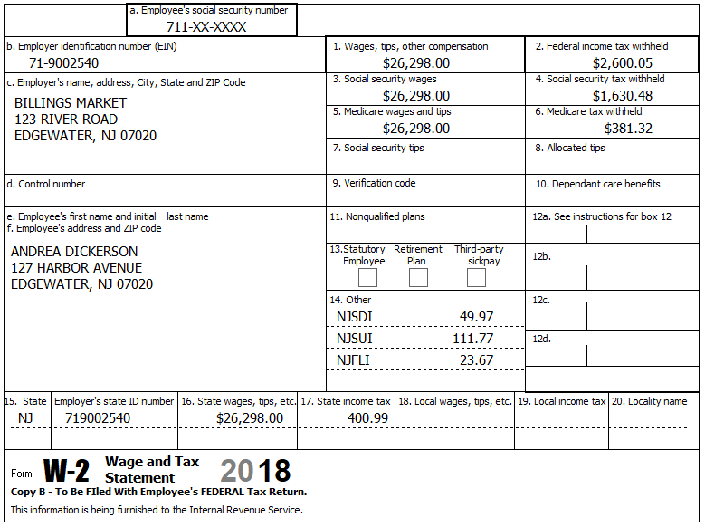

Federal AGI: 26,298 Federal Refund: 1,077 NJ Refund Amount: 29

Step 3 Interest 1099-INT

TP Form / Note | TS Screen | Notes
1099-INT  Big City Bank | Income  Interest and Dividends Form 1099-INT/ 1099-DIV- Begin  Interest or Dividend Income -Begin  Interest Income, Form 1099-INT  Continue | Hint: Select for Taxpayer  Enter values that apply.  Hint: It is not required to enter the EIN and address.  ““Continue””
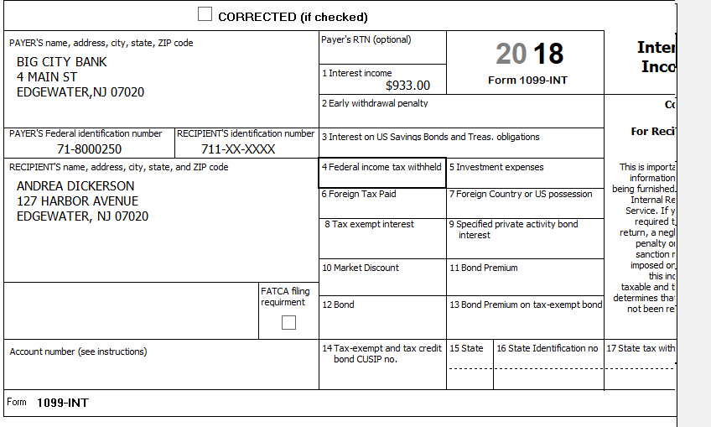

Federal AGI: 27,231 Federal Refund: 963 NJ Refund Amount: 12

Step 4 Student Loan Interest
TP Form / Note | TS Screen | Notes
I-Note 2 | Left Menu  Federal Section – Deductions  Enter Myself  Adjustments - Begin  Student Loan Interest Deduction - Begin | Enter Student Loan Interest Amount  “Continue”
Andrea paid $167 in student loan interest in the current tax year

Federal AGI: 27,064 Federal Refund: 981 NJ Refund Amount: 12

Step 5 Itemized Deductions – Taxes You Paid
TP Form / Note | TS Screen | Notes
I-Note 4 | Left Menu-Federal Section -Deductions – Enter Myself  Itemized Deductions – Begin  Taxes You Paid - Begin | TS: Go to ADD SALES TAX WORKSHEET and enter ZIP Code and 365 days living in NJ  “Continue””
.
Federal AGI: 27,064 Federal Refund: 981 NJ Refund Amount: 12
Step 6 Compare Standard vs Itemized Deductions

TP Form / Note | TS Screen | Notes
 | Federal Section  Deductions  Enter Myself  Compare Deductions - Begin | TS: Check to see if using itemized or standard deductions.  Itemized = $587  Std = $12,000  Hint: You can view Schedule A (Itemized Deductions) by clicking on the Print Icon next to Itemized Deductions in the Deductions Menu.  “Continue”

Federal AGI: 27,064 Federal Refund: 981 NJ Refund Amount: 12
Step 7 Health Insurance

TP Form / Note | TS Screen | Notes
G-Note 2 | Left Menu-Health Insurance  Health Insurance Questionnaire  Did you or your family have health insurance or qualify for a coverage exemption at any time in 2018?  Did you purchase insurance via HealthCare.gov of a State Marketplace?  Verify Your Household Members  Months Insured  Was your entire household covered by qualifying health care coverage or a coverage exemption that covered 2018 or a combination of qualifying health care coverage and coverage exemptions for every month of 2018? | Answer questions in the Health Insurance Section  TS – Yes  “Continue”  TS – No  “Continue”  TS – Always select ““Continue””  TS-Yes  “Continue”

Andrea had health insurance that met Minimum Essential Coverage rules for the entire year. She did not purchase it through the marketplace.

Federal AGI: 27,064 Federal Refund: 981 NJ Refund Amount: 12
Step 8 New Jersey Return

TP Form / Note | TS Screen | Notes
I-Note 1,  G-Note 2,3,4 | State Return –Edit  Basic Information - Edit  Credits  - Property Tax Credit/Deduction-Begin | Hint: Use the NJ Checklist to enter NJ items  TS: Complete Basic Information.  Hint: Gubernatorial Election Fund: Andrea -No  “Save”  Hint: Taxpayer meets Property Tax Eligibility Requirements  Hint: Use scratch pad at TP4F to determine the proper value for Property Tax Paid  - Hint: Property Taxes Paid = (rent*.18) . (12,000*.18) = $2,160  Hint: Taxpayer was not a homeowner in 2018  Save back to the beginning of the State Return

Andrea paid $1,000.00/month rent for the tax year.
She did not have any out-of-state purchases on which she did not pay use tax.

Federal AGI: 27,064 Federal Refund: 981 NJ Refund Amount: 62

Step 14 Prepare for e-file
Intake Sheet  G Note 5 | Left Menu – e-file –  Federal Return Type  Fees  State Return Type  Third Party Designee Info  Consent to Disclose  Questions  Taxpayer ID Information | TS – Clear up any diagnostic messages (if any)  TS: Select “E:file: Paper Check”  Next  TS: No entries in Fees section except for Client email address  Next  TS: Select State Refund Type “E:file: Paper Check”  Next  TS: Skip Third Party Designee. It is Out of Scope for us.  Next  TS: Consent to Disclose Tax Return Information – Check GRANT  and enter 5 digit pin (any 5 digit number) and date for TP.  Next  TS – Questions – Answer questions from Intake sheet Part VII, lines 5.6,7 and 8  - Assume taxpayer was present  Next  TS: Skip TP ID Information Screen. Not required for NJ.  Save  You are Done

She wants to handle any state refund / amount due like their federal refund / amount due.

Federal AGI: 27,064 Federal Refund: 981 NJ Refund Amount: 62

